Stacks of Wax Report – Kiera Wright 40079955

For this project I have created a vinyl collection website, this site allows non-members to view vinyl’s and vinyl collections, with members able to create collections and comment and like other members collections. In this project I used visual studio code to build the website with HTML, CSS and JavaScript, with use of node and express JS. I also used a CSS library to help with the look of the website, I used Bootstrap 5.3 as well as some icons from Font Awesome. The website allows you to filter the vinyl’s by genre, likes and artist, and when clicked on will display details of that vinyl. The collections displayed show what vinyl’s are included as well as a description of the collection. The collections can be liked and comments added, but only by members.

Entity Relationship (ER) diagram

The initial design for this database was simple, it needed to have a member that could make a collection made up of vinyl records. To develop this I started with 3 basic tables of member, collection and vinyl, and from this developed further to ensure the constraints worked correctly. For this project as the main focus isn’t the database design, I didn’t focus too much on normalization, and therefore, there is room for improvement in this basic database.

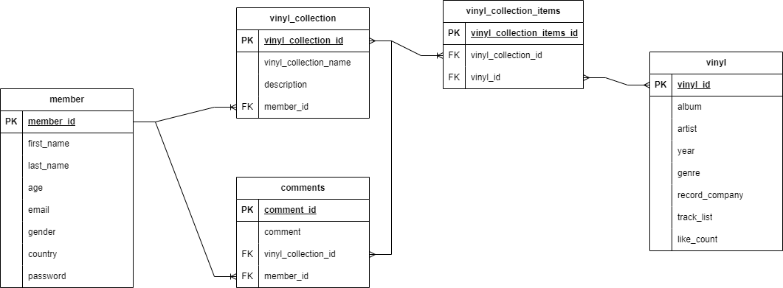

Fig. 1 Stacks of Wax ER diagram

As shown in figure 1, the collection table is the main link between all the components, there is a separate table for each vinyl in the collection so as to allow for more than one vinyl to be assigned to a collection. The database design also allows for liking albums and comment on collections.

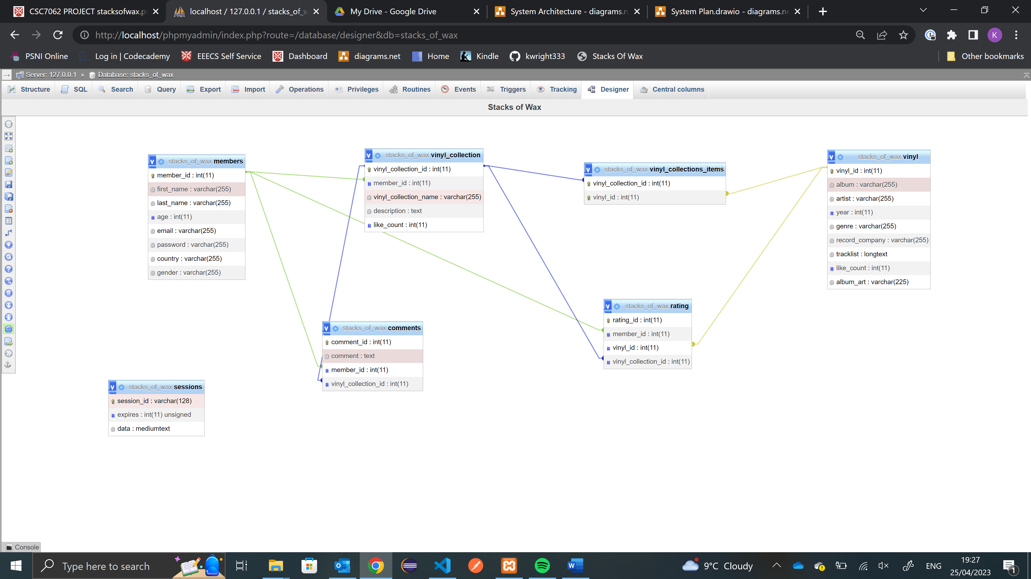

Fig 2. Stacks of Wax Database

The final databases had some changes made to it, a like count was added to the collections to allow them to be liked as well as commented, as well as adding a rating table to link the members to what they like. The vinyl collection items have a composite key as the primary key and album art was added to the vinyl table to aid display on the website. There is also a sessions table which is used to store user session data, which is used to keep the user logged in as they move about the site.

High-level description of system developed

A web applications that allows a user to browse the site, see the collections on the site as well as all vinyl records that are available to add to a collection, all as a non-member. As a member they can create collections from the vinyl records available as well as like vinyl records and like and comment on collections.

On the home page of this site there is a header including a logo for the site which is a home button, a navigation bar for the main pages which collapses into a hamburger menu when on a smaller screen, a login/register button as well as a search bar. This header stays on the top of the page when scrolling and is on all pages apart from the login and register pages. The home page itself contains a brief description of the site as well as the top nine rated vinyl records and the top three collections. Also displayed is the vinyl records on the site that have been released this year as well as some informative YouTube videos.

From the nav bar, the vinyls page is accessible. This page includes a list of the vinyl records in the database, displayed in rows of four by the album art. When hovering over the album art of a vinyl record, it will show the artist name and the name of the album. This can then be clicked on to give a pop up which gives more details of this album. The details include the track list, the year, the genre, the record company and the like count. From this pop up, if logged in, the vinyl can be liked. The list of vinyl records can also be filtered by genre, likes or by artist, these filters are done by drop down menus above the albums.

The collections are displayed on a different page, and they are displayed as cards in rows of two. The cards show the vinyl records by way of the art, with the collection name and the description displayed below as well as the like count. The collection card has a more details button, which will bring up a pop up which displays the album name of all the vinyl records in the collection as well as the first name of the person who created it. If logged in there will also be a comments button, which will bring up the comments on that collection as well as a box to add a comment, as well as the like button.

To log into this site the user can click on the login/register button which will bring them to a login screen which has fields for the email address and the password as well as the site logo which is a home button. By clicking the login button, if the details are correct, the user will be redirected to the home page with the members page now available on the header. If the user has not registered yet, they can select the register link on the login page which will bring them to a form to complete with all their details.

On the members page, the users details will be displayed along with an add collection button, which allows the user to create a collection on a pop up, name it, give it a description and add the vinyl records from a drop down list. The collections for the member will then be displayed down the right hand side of the page, in the same card format as the collections page. The more details, comments and like button will be the same but there will be an additional edit button, which allows the user to change the name, description and the vinyl records in the collection.

Brief analysis of your development approach (Maximum of 3 A4 pages)

I started the creation of this website using basic HTML and CSS to create a home page with the use of the CSS library bootstrap, and to get started with this I made a basic diagram of how I wanted the page to look.

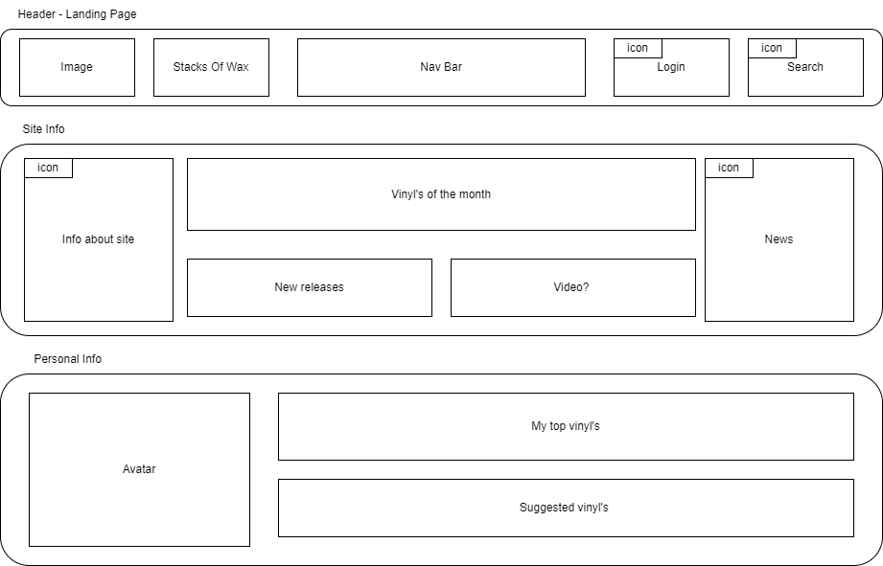

Fig. 3 Diagram of the landing page

I created this diagram as a starting point for the style of the page and what content I wanted it to include. The first thing I created with the header, which I wanted to be able to include in my other pages. I created this

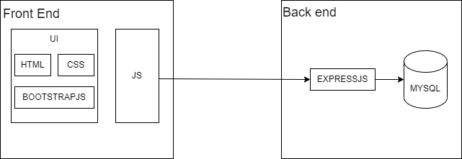

Instructions on how to run the system (locally – it is a requirement I can run your system locally). (Maximum of 2 A4 pages)

URI of MS STREAM video demonstration of your system

References to external code snippets, libraries, dependencies etc. (No need to reference media assets)

* Bootstrap 5.3
* Font Awesome 6.4.0
* mdbootstrap.com
* bbbootstrap.com